Song: Mii Channel Theme
Author: Wii
Key: E
Signature: 4/4
BPM: 110
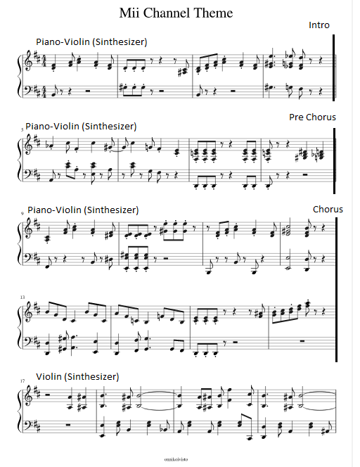
Sections (Parts of the song):
